Imperial Conclave

of the Masonic and Military Order
of the Red Cross of Constantine
and the Orders of the Holy Sepulchre
and St. John the Evangelist
for England and Wales
and its Divisions and Conclaves Overseas

Division of West Lancashire
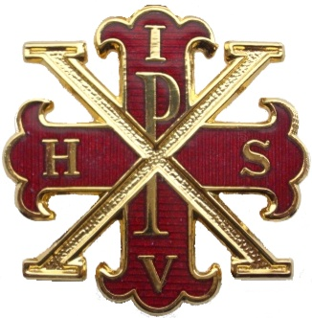

In hoc Signo Vinces
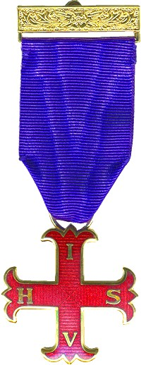
As a Royal Arch Mason, if you profess a belief in the Christian Faith you are qualified to become a member of the Order of the Red Cross of Constantine.

The earliest record of the Red Cross of Constantine degree was in Scotland in the late 1700’s. The Order assumed its current form following the establishment of Grand Imperial Conclave in London in 1865 by Robert Wentworth Little, an employee at Freemasons’ Hall. Since that time, this Chivalric Order has grown steadily with the formation of a number of sovereign Grand Conclaves throughout the world.

The moral teachings of the Order are based upon the legendary influences that Christianity had upon the life of Constantine the Great, which culminated in his being baptised into the faith shortly before his death in 337 A.D.

Constantine’s father was one of four joint rulers of the Roman Empire, being the Caesar (Emperor) of the Western Province. Constantine had joined his father to quell an uprising in Britain. When his father died, Constantine was hailed as Caesar by the legions in York in 306 A.D, which was grudgingly accepted by the Augustus (Senior Emperor) in Rome.

Following attempts to undermine his position by Maxentius in Rome, Constantine resolved to seek justice and retribution by marching on Rome with his army.

One day on the march to Rome, Constantine and his army saw what they believed was a sign from Heaven, a pillar of light in the sky in the form of a special cross, with an inscription foretelling victory. Constantine therefore had made a standard bearing a Cross like that seen, and ordered it to be carried before him in his battles.

Following victory over Maxentius, the Senate proclaimed Constantine, Augustus Maximus (the Senior Emperor). Having later defeated the Augustus of the Eastern Province, Constantine became sole ruler of the Roman Empire. He then transferred the capital from Rome to Byzantium, later re-named Constantinople in his honour.

Constantine was the first Roman Emperor to openly embrace and encourage Christianity. At his instigation, several Councils of Bishops were established which laid down a firm basis of Christian liturgy and belief.

The first of our ceremonies consists of the Candidate’s admission, obligation and then the installation as a Knight Companion of the Red Cross of Constantine, in which the historical basis of the Order is also detailed.

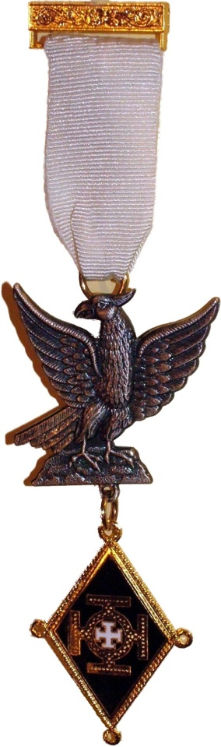
The second ceremony, that of the Knights of the Holy Sepulchre and St. John the Evangelist is undoubtedly amongst the most impressive in Masonry, an experience that is enhanced by the sword drill of the Sepulchre Guard. The presence of the Guard is a powerful reminder that this is not only a Masonic but also a Military and Chivalric Order. The ceremony culminates with an explanation of the ultimate aims of the Craft.

Regalia for Knights consists of, as a minimum, a sash and a jewel. Swords are a necessary addition for some offices.

Most Conclaves meet three or four times a year. Two special Conclaves, Sovereigns’ Unity Conclave (where membership is open to Knights who have made progress in the Order) and Constantine Conclave (Divisional and Illustrious Knights), each meeting twice a year, can also be visited by Knights of the Order.

The Division of West Lancashire is one of the largest in the country. The Annual Meeting of the Division is held in Leyland on the first Saturday in September followed by a luncheon.

Our charity giving focusses mainly on children’s charities and the last six years have seen donations to: The Grand Sovereign’s Care for Children Fund - £2,600; Derian House - £1,850; Legacy Rainbow House - £1,700; NW Air Ambulance - £600 - A total of £6,750.

A list of all the Conclaves in the Division of West Lancashire is given overleaf. If you need any further help or information, please contact the Divisional Recorder, who will be only too pleased to assist you, or visit the website.

Michael Robert Walker

Right Illustrious Knight Michael Robert Walker
Intendant General
WEST LANCASHIRE RED CROSS CONCLAVES
CONCLAVE | LOCATION
St. Georges No. 42 | Chorley
Lancastrian No. 164 | Widnes
Red Rose No. 188 | Widnes
Warrington No. 206 | Warrington
Agnus Dei No. 220 | Southport
The Leonard Heeley No. 241 | Pemberton
Westhoughton No. 254 | Westhoughton
Constantine No. 261  (Knights must hold Grand or Divisional rank to be eligible for membership) | Pemberton
Dr. W.R. Waters No. 269 | Leigh
Prescot No. 291 | Prescot
Ormskirk No. 294 | Ormskirk
Rose Hill No. 298 | Bryn
Hesketh No. 309 | Leyland
Swinton No. 355 | Swinton
Croston No. 362 | Croston
St. Helena No. 378  (A conclave for Sepulchre Guard members, but not exclusively)) | St. Helens
Sovereigns’ Unity No. 406  (Knights who have progressed in their conclaves to General are eligible for membership) | Leyland

To find out more about this Order go to:-
www.westlancsrcc.org.uk
or email the Divisional Recorder at
recorder@westlancsrcc.org.uk

